WATERSHED INDIA- empowering citizens

Strategic Partnership – India Work Programme
Village Information Sheet
1. State: Odisha
2. District: Ganjam 3. Block: Chatrapur
4. Name of gram panchayat: Arijayapalli 5. Name of village: SanaAriayapalli
6. Population of village: 792 7. Total Household:-.2800
8. Connectivity: Pucca/Kucha Road : Pucca
9. Distance from District headquarters: 09 km
10. Number of hamlets ( Pada /Sahi) : 15
11 . Name of Pada/Sahi 1:-Gandhi Chaka Sahi 2:-Nua Sahi 3:-Akaidi Sahi 4:-Ganapati Sahi 5:-Hatta Sahi 6:-Pitambar Sahi 7:-Kanda Sahi 8:-Rajama Sahi 9:-Subash Chandra Bose Sahi 10:-Kalimukhi Sahi 11:-Tala Sahi 12:-Bhandari Sahi 13:-Thakurani Sahi 14:-Khandia Sahi 15:-Gopi Sahi
11.Social Group:- 1:- Nolia 2:-Sundhi 3:-Teli 4:-Dandasi 5:-Kumuti 6:-Brahamini 7:-Bhandari 8:-Badhei 9:-Gudia 10:-Kandara
12.Religion .Hindu& christian
13. Social Group wise Catagory:-
General Category | S C Category | S T Category | OBC Category
Brahmin | Dandasi | 0 | Nolia
0 | Candara | 0 | Teli
0 | 0 | 0 | Sundhi
0 | 0 | 0 | Bhandari
0 | 0 | 0 | Gudia
0 | 0 | 0 | Kumuti
0 | 0 | 0 | Badhei

14. Sahi/Pada wise House hold(Social Group)
SN | Name of the Hamlet/Sahi | Household (general) | Household (SC) | Household (ST) | Household (OBC) | Total
1 | Gandhi Chaka sahi | 02 | 10 | 0 | 68 | 80
2 | Nua Sahi | 0 | 0 | 0 | 50 | 50
3 | Akaidi Sahi | 01 | 0 | 0 | 21 | 22
4 | Hatta Sahi | 0 | 0 | 0 | 20 | 20
5 | Kanda Sahi | 0 | 0 | 0 | 25 | 25
6 | Rajama Sahi | 03 | 0 | 0 | 57 | 60
7 | Subash Chandra Bose Sahi | 0 | 0 | 0 | 100 | 100
8 | Kalimukhi Sahi | 0 | 0 | 0 | 45 | 45
9 | Tala Sahi | 0 | 01 | 0 | 79 | 80
9  10 | Bhandari Sahi | 0 | 01 | 0 | 29 | 30
11 | Thakurani Sahi | 0 | 0 | 0 | 80 | 80
12 | Ganapati Sahi | 0 | 0 | 0 | 50 | 50
13 | Pitambar Sahi | 0 | 0 | 0 | 30 | 30
14 | Khandia Sahi | 0 | 0 | 0 | 80 | 80
15 | Gopi Sahi | 0 | 0 | 0 | 40 | 40
 | Total | 06 | 12 | 0 | 774 | 792

15.Sahi /pada wise Oqupation
 | Gandhi Chaka sahi | Nua Sahi | Akaidi Sahi | Hatta Sahi | Kanda Sahi | Rajama Sahi | Subash Chandra Sahi | Kalimukhi Sahi | Tala Sahi | Bhandari Sahi | Thakurani sahi | Khandia Sahi | Gopi Sahi | Ganapati Sahi | Pitambar sahi
 | 1 | 2 | 3 | 4 | 5 | 6 | 7 | 8 | 9 | 10 | 11 | 12 | 13 | 14 | 15
Fishing | 70 | 50 | 22 | 20 | 25 | 55 | 100 | 45 | 79 | 03 | 80 | 80 | 40 | 50 | 30
Marginal Farmer (<2.5Acer) | 02 | 0 | 0 | 01 | 0 | 03 | 04 | 03 | 06 | 03 | 04 | 01 | 03 | 02 | 01
Medium/large Farmer>2.5 | 0 | 0 | 0 | 0 | 0 | 0 | 0 | 0 | 0 | 0 | 0 | 0 | 0 | 0 | 0
Labourers | 70 | 50 | 22 | 20 | 25 | 55 | 100 | 45 | 79 | 30 | 80 | 80 | 40 | 50 | 30
Service |  |  |  |  |  | 01 |  |  | 05 |  |  |  |  |  | 01
Small Business | 05 | 02 | 22 | 01 | 0 | 03 | 01 | 02 | 02 | 0 | 03 | 0 | 02 | 01 | 0
Keoda collection | 0 | 0 | 0 | 0 | 0 | 0 | 0 | 0 | 0 | 0 | 0 | 0 | 0 | 0 | 0
Keoda Processing | 0 | 0 | 0 | 0 | 0 | 0 | 0 | 0 | 0 | 0 | 0 | 0 | 0 | 0 | 0

16. Income Generation Unit in Village:-
1) Kaju Processing Unit - 01 In Near village Kanamana
2) Keoda processing Unit-02 in Near village At Kanamana
3; Incomegeneration Activites. Gopalpur Port Fishing Jethi, IRE & Port Labour work.
17. Functional Village Water & sanitation Committee: - NO
18. Numbers of user / pani committee in the village:-NO
No separate Committee for water users ,Village GKS not Functioning deu to Hamlet village.
19. Institution Mapping:-
SN | Institution | Type | Distance to Village | No of Centre | Key Authority/Point person | Role
1 | Anganwadi Center | Center | In Village | 04 | AWW | Health
2 | School | Praimery | In Village | 01 | Head Master | Education
3 | Health Center |  | In Village |  | ANM | Health
4 | NGO | NO | NO | NO | NO
5 | Bank | All Bank | Chatarpur IRE |  |  | Loan
6 | SHG |  | In Village | 06 | SGH Leader | Loan
7 | Post office | Village post Office | Arijayapalli | 01 | Post Master | Comunication
8 | Panchayat Office |  | Arijayapalli | 01 | Sarapancha | Village Devlopment
9 | Police Station | Meraine | Arijayapalli | 01 | Police Inspector | Protection
20. Main Source of Drinking Water:-
SN | Type Recourse | Nos/ units | Coverage (%Villagers) | Function
1 | Pipe water System Household connecting | O1 | 25% | Pipe water conection Only ODRP Schem
2 | Hand Pump | 10+27 | 75% | Function
3 | Open well | 0 | 0 | 0
4 | Personal Burwell | 210 | 30% | Function
5 | Personal open well

21. Sanitation Coverage:-
SN | Type | %of village population
1 | Toilet Coverage | 40% | ODRP Schema Shelter with Pipe water Toilet Facility
2 | Toilet Usage | 60% | Out Side Practice

22) Resource Map & Social Map
1) Resource Map
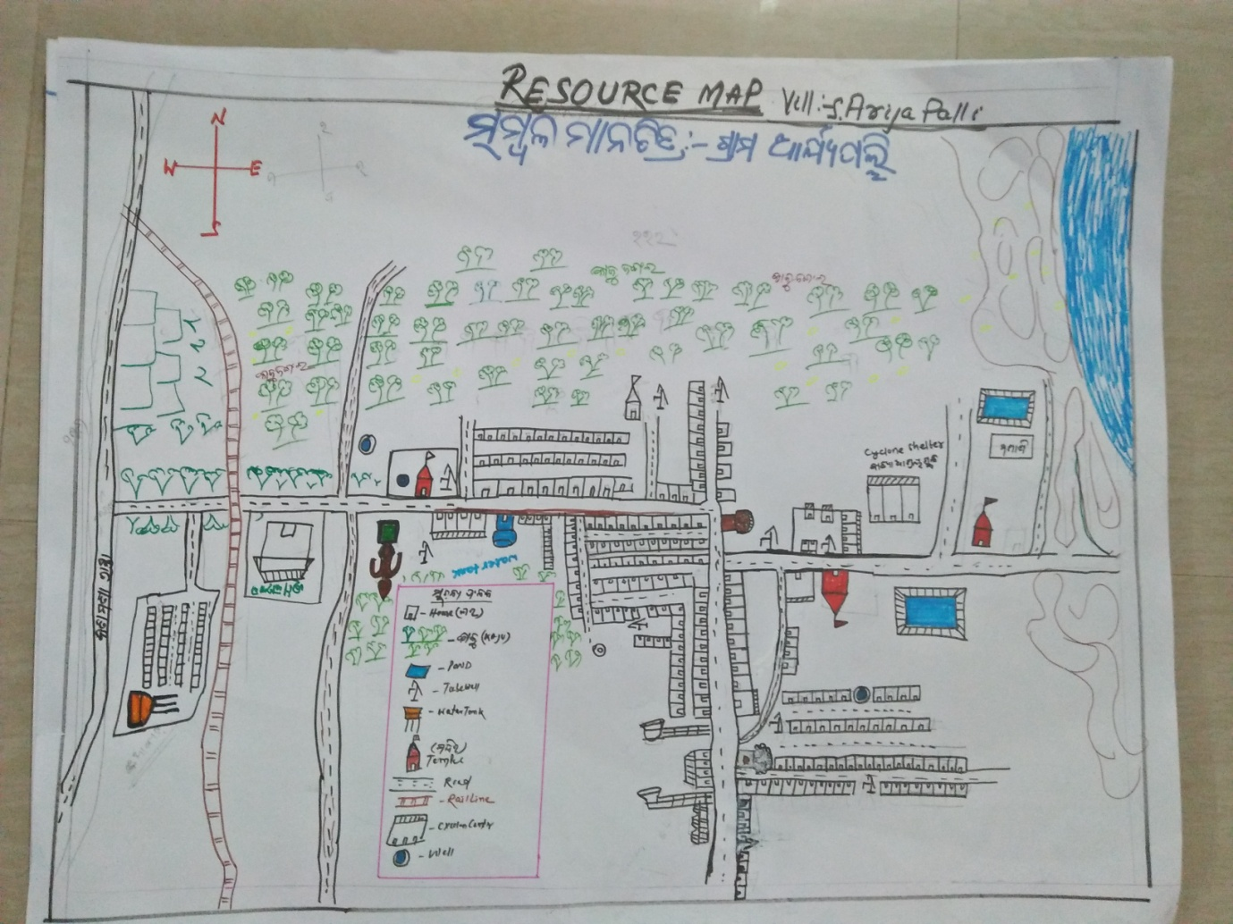
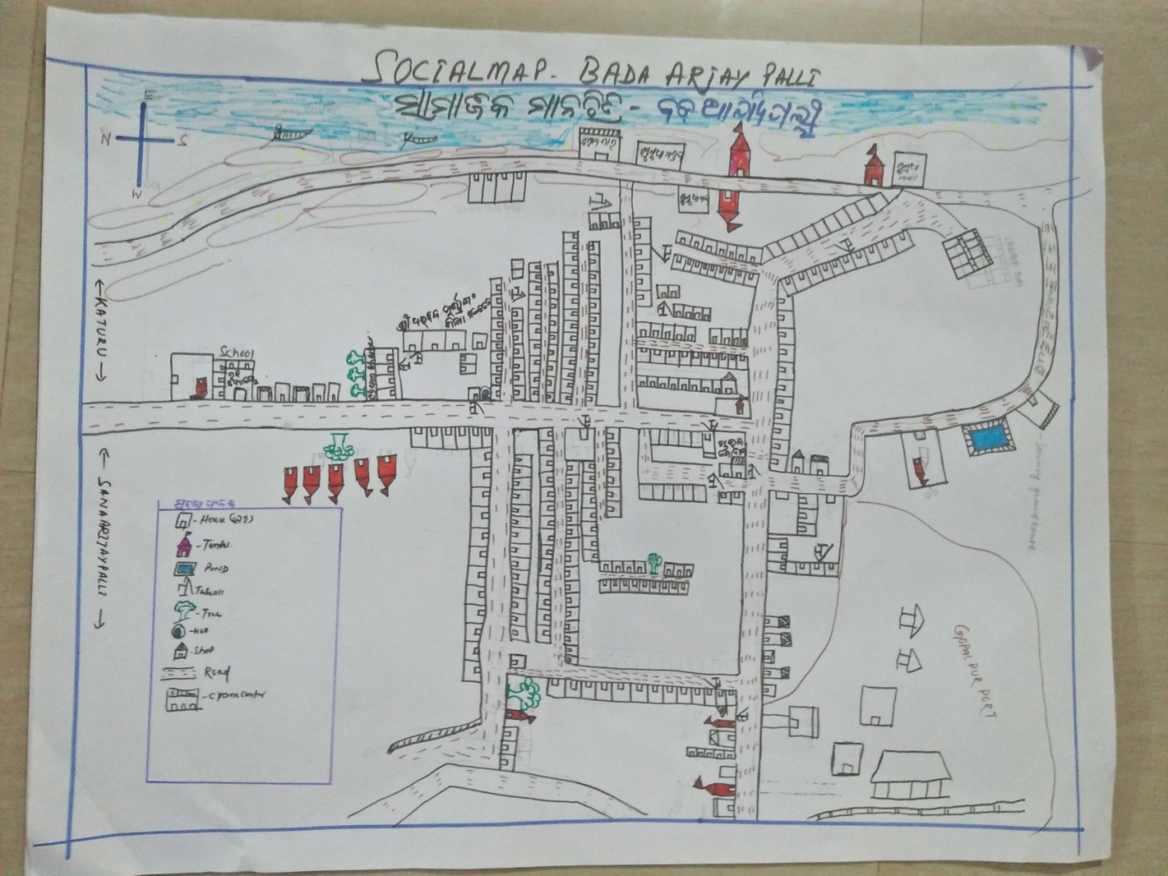
2) Social Map
23 . Water Bodies;-
SN | Surface water Bodies | Period for Which water Available | Purpose of Use | For Eache purpose indicate Month (From –to) | Who Manage
1 | Sea Bay of Bengal |  | Fishing |  | GOD
2 | Chanel & Canal | NO
3 | Lake | NO
4 | Pond | 10months | Bath & Wash | July To April
5 | Open Dug well | Full time | Bath& Wash
(Mark on Resource Map )
24. Seasonal Calendar For Resources Availability:-
 | Jan | Feb. | Mar | Apr | May | June | july | Aug | Sept | oct | Nov | Dec
Capture Fishing | √ | √ | √ | 0 | 0 | 0 | √ | √ | √ | √ | √ | √
Culture Fishing | 0 | 0 | 0 | 0 | 0 | 0 | 0 | 0 | 0 | 0 | 0 | 0
Aquatic plant collection | 0 | 0 | 0 | 0 | 0 | 0 | 0 | 0 | 0 | 0 | 0 | 0
Agriculture | 0 | 0 | 0 | 0 | 0 | 0 | √ | √ | √ | √ | 0 | 0
Kaju collecting |  |  | √ | √ | √
Labour Work | √ | √ | √ | √ | √ | √ | √ | √ | √ | √ | √ | √
Fish Trading | √ | √ | √ | √ | 0 | 0 | 0 | 0 | 0 | √ | √ | √

25. Hazard & Vulnerability Mapping :-
SN | Type of Hazard | Year of Hazard | Period of Hazard | If flood days when water Water logging | Areas Inundated
1 | Super cyclon | 1999 | october | N A | NA
2 | Phailin | 2013 | october | N A | NA
26. Time &Trained Analysis of Resource Vulnerability:-
SN | Year | Type Hazard/Event | Effect/ affect Waterresourse
1 | 1999 | Super Cycone | Pond & Tube well fill with Slain water in Down area.
2 | 2013 | Phailin | Pond & Tube well fill with Slain water in down area
3 | 2014 | Hoodhud | No

