WATERSHED INDIA- Empowering Citizens

Strategic Partnership – India Work Programme
Village Information Sheet
1. State: Odisha
2. District: Ganjam 3. Block: Chatrapur
4. Name of gram panchayat: _ Podapadar 5. Name of village:-Podapadar
6. Population of village: 2255 7. Total Household:-508
8. Connectivity: Pucca/Kucha Road : Pucca
9. Distance from District headquarters:-04km
10. Number of hamlets ( Pada /Sahi) : 12
11 . Name of Pada/Sahi 1:- Road Sahi.2:- Maluani Sahi 3:- Gandhi Nager 4:-Munika Sahi 5:- Dasiri Sahi 6:- Majhi Sahi 7:-Talasahi 8:- Brahmana Sahi 9:- Tala Bauri Sahi 10:- Upara Bauri sahi 11:-Indira abas Sahi 12:-Durga Nager
12.Social Group:- 1:-Gola 2:-Palia 3:- Bhandari 4:- Gouda 5:- Brahamin 6:- Sundi 7:-Badhei 8:-Gudia 9:-Dandasi 10:-Bauri 11: Dhoba 12: Teli 13: Hadi
13.Religion .Hinhu
14. Social Group wise Catagory:-
General Category | S C Category | S T Category | OBC Category
Bramhani | Dhoba | 0 | Gola
0 | Bauri | 0 | Palia
0 | Hadi | 0 | Bhandari
0 | Dandasi | 0 | Gouda
0 | 0 | 0 | Badhei
0 | 0 | 0 | Sundhi
0 | 0 | 0 | Telli
 | 0 | 0 | Gudia

14. Sahi/Pada wise House hold(Social Group)
SN | Name of the Hamlet/Sahi | Household (general) | Household (SC) | Household (ST) | Household (OBC) | Total
1 | Road Sahi | 07 | 10 | 0 | 183 | 200
2 | Maluani Sahi | 0 | 0 | 0 | 15 | 15
3 | Gandhi Nager | 0 | 0 | 0 | 50 | 50
4 | Munika Sahi | 0 | 0 | 0 | 35 | 35
5 | DasiriSahi | 0 | 4 | 0 | 71 | 75
6 | Majhi Sahi | 0 | 02 | 0 | 118 | 120
7 | Tala Sahi | 04 | 0 | 0 | 96 | 100
8 | Bramhana sahi | 32 | 05 | 0 | 3 | 40
9 | Tala Bauri Sahi | 0 | 20 | 0 | 0 | 20
10 | Uparbaurisahi | 0 | 22 | 0 | 0 | 22
11 | Indirabas Sahi | 0 | 15 | 0 | 0 | 15
12 | Durga Nager | 0 | 0 | 0 | 07 | 07

15.Sahi /pada wise Oqupation
 | Road Sahi | Maluani Sahi | Gandhi Nagar | Munika Sahi | Dasiri Sahi | Majhi Sahi | Tala Sahi | Brmhana Sahi | Talabauri Sahi | Urar bauri sahi | Indrabas Indabas Sahi | Druga Nager
 | 1 | 2 | 3 | 4 | 5 | 6 | 7 | 8 | 9 | 10 | 11 | 12
Fishing | 0 | 0 | 0 | 0 | 0 | 0 | 0 | 0 | 0 | 0 | 0 | o
Marginal Farmer (<2.5Acer) | 195 | 15 | 47 | 30 | 8 | 100 | 100 | 30 | 0 | 0 | 0 | 0
Medium/large Farmer>2.5 | 05 | 0 | 3 | 2 | 2 | 5 | 04 | 05 | 0 | 02 | 0 | 1
Labourers | 100 | 10 | 47 | 30 | 69 | 100 | 100 | 08 | 15 | 20 | 15 | 07
Service | 6 | 2 | 01 | 05 | 06 | 06 | 05 | 03 | 05 | 05 | 0 | 0
Small Business | 75 | 15 | 20 | 05 | 69 | 15 | 15 | 08 | 05 | 0 | 0 | 0
Keoda collection | 10 | 3 | 02 | 5 | 03 | 05 | 05 | 05 | 0 | 0 | 0 | 0
Kaju Processing | 30 | 05 | 05 | 08 | 05 | 10 | 10 | 0 | 0 | 0 | 0 | 0

16. Income Generation Unit in Village:-
1) Kaju Processing Unit .....................
2) Keoda Processing Unit..............................
3; Incomegeneration Activites/Unit...................................
17. Functional Village Water & sanitation Committee: - .............
18. Numbers of user / pani committee in the village:-
No separate Committee for water users ,Village GKS Functioning & Same Member in both Committee.
19. Institution Mapping:-
SN | Institution | Type | Distance to Village | No of Centre | Key Authority/Point person | Role
1 | Anganwadi Center
2 | School
3 | Health Center
4 | NGO
5 | Bank
6 | SHG
7 | Post office
8 | Panchayat Office
9 | Police Station
20. Main Source of Drinking Water:-
SN | Type Recourse | Nos/ units | Coverage (%Villagers) | Function
1 | Pipe water System Household connecting
2 | Hand Pump
3 | Open well
4 | Personal Burwell
5 | Personal open well

21. Sanitation Coverage:-
SN | Type | %of village population
1 | Toilet Coverage
2 | Toilet Usage
22. Resource Map & Social Map
1) Resource Map
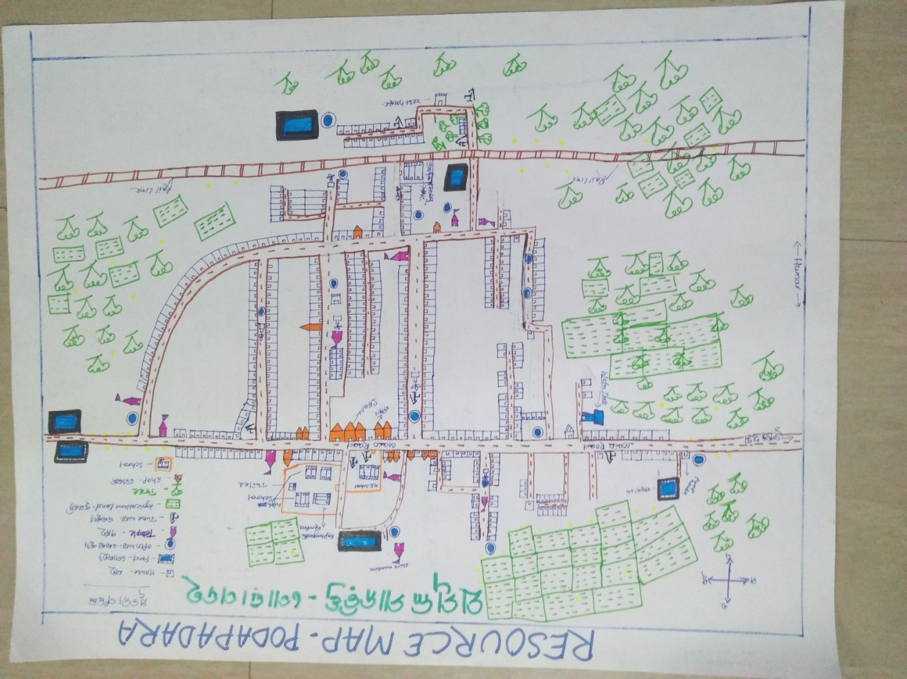

2) Social Map
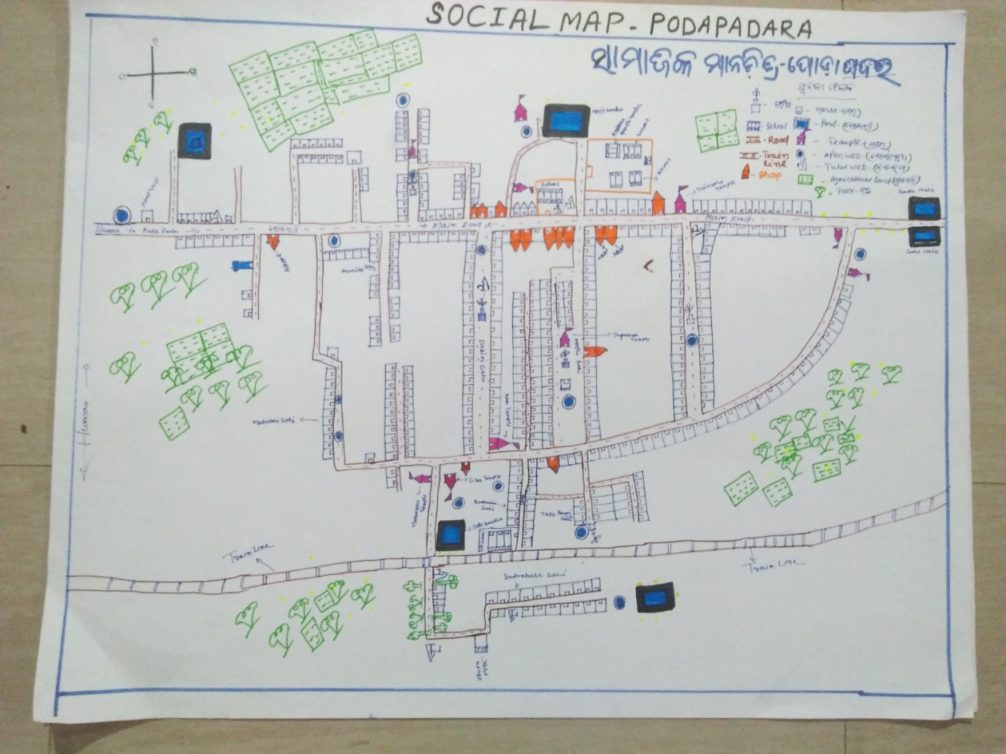
23 . Water Bodies;-
SN | Surface water Bodies | Period for Which water Available | Purpose of Use | For Eache purpose indicate Month (From –to) | Who Manage
1 | River & Stream
2 | Chanel & Canal
3 | Lake
4 | Pond
5 | Open Dug well
(Mark on Resource Map )
24. Seasonal Calendar For Resources Availability:-
 | Jan | Feb. | Mar | Apr | May | June | july | Aug | Sept | Oct | Nov | Dec
Capture Fishing
Culture Fishing
Aquatic plant collection
Agriculture
Kaju collecting
Keoda collection

25. Hazard & Vulnerability Mapping :-
SN | Type of Hazard | Year of Hazard | Period of Hazard | If flood days when water Water logging | Areas Inundated
1 | Super cyclon | 1999
2 | phailin | 2013

26. Time &Trained Analysis of Resource Vulnerability:-
SN | Year | Type Hazard/Event | Effect/ affect Waterresourse
1 | 1999 | Super Cycone | Pond & Tubewell fill with Salain water
2 | 2013 | Phaini | Pond & Tubewell fill with Salain water
3 | 2014 | Hoodhud

