WATERSHED INDIA- Empowering Citizens

Strategic Partnership – India Work Programme
Village Information Sheet
1. State: Odisha
2. District: Ganjam 3. Block: Chatrapur
4. Name of Gram Panchayat: Kanamana 5. Name of village: .Takiria Berhampur
6. Population of village: 283 7. Total Household:-1340
8. Connectivity: Pucca/Kucha Road: Pucca
9. Distance from District headquarters: -06 km
10. Number of hamlets ( Pada /Sahi) : -10
11 . Name of Pada/Sahi 1:- Kanakadruga Sahi 2;-Nayaka Sahi 3:- Bari Sahi 4:- School Sahi 5:-Marada Sahi 6:- Thakurani madir Sahi 07: Radhakrushna Mandir Sahi 8:-Patra Sahi 9:-Nua Sahi 10:- Pail Sahi
11. Social Group:- 1:- Brahman 2:-Redy 3:-Dhoba 4: Nolia 5:-Lihari 6:- Dandashi 7:- Sahoo 8: -Badhei 9: Doma 10 :Khandayat
12.Religion :- Hindu
13. Social Group wise Catagory:-
General Category | S C Category | S T Category | OBC Category
Brahmana | Dandashi | 0 | Khandayat
0 | Dhoba | 0 | Sahoo
0 | Damo | 0 | Reddy
0 | 0 | 0 | Badhei
0 | 0 | 0 | Lihari
 |  |  | Nolia

14. Sahi/Pada wise House hold(Social Group)
SN | Name of the Hamlet/Sahi | Household (general) | Household (SC) | Household (ST) | Household (OBC) | Total
1 | Kanakadruga Sahi | 3 | 10 |  | 19 | 32
2 | Nayaka Sahi | 0 | 15 | 0 | 0 | 15
3 | Bari Sahi | 0 | 0 | 0 | 10 | 10
4 | School Sahi | 0 | 10 | 0 | 57 | 67
5 | Marada Sahi | 0 | 0 | 0 | 15 | 15
6 | Thakurani madir Sahi | 01 | 3 | 0 | 16 | 20
7 | Radhakrushna Mandir Sahi | 32 | 10 | 0 | 0 | 42
8 | Patra Sahi | 0 | 35 | 0 | 5 | 40
9 | Nua Sahi | 0 | 10 | 0 | 12 | 22
10 | Payal Sahi | 0 | 5 | 0 | 15 | 20

15.Sahi /pada wise Oqupation
 | Kanakadrgua Sahi | Nayaka Sahi | Bari Sahi | School sahi | Marada Sahi | Thakurani madir Sahi | Radhakrushna Mandir Sahi | Patra sahi | Nuasahi | Payal Sahi
 | 1 | 2 | 3 | 4 | 5 | 6 | 7 | 8 | 09 | 10
Fishing | 0 | 0 | 0 | 0 | 0 | 0 | 0 | 0 | 08 | 0
Marginal Farmer (<2.5Acer) | 8 | 01 | 10 | 20 | 0 | 05 | 27 | 03 | 03 | 12 | 89
Medium/large Farmer>2.5 | 0 | 0 | 0 | 0 | 0 | 0 | 03 | 0 | 0 | 0 | 03
Labourers | 31 | 15 | 19 | 63 | 13 | 19 | 38 | 40 | 18 | 20 | 279
Service | 03 | 0 | 01 | 04 | 02 | 01 | 04 | 0 | 01 | 03 | 19
Small Business | 05 | 0 | 0 | 02 | 0 | 0 | 02 | 0 | 01 | 0 | 10
Keoda collection | 04 | 0 | 05 | 35 | 2 | 4 | 35 | 0 | 03 | 17 | 105
Keoda Processing | 0 | 0 | 0 | 0 | 0 | 0 | 0 | 0 | 0 | 0 | 0

16. Income Generation Unit in Village:-
1) Kaju Processing Unit -01
17. Functional Village Water & sanitation Committee: - No
18. Numbers of user / pani committee in the village:-NO
No separate Committee for water users ,Village GKS Functioning
19. Institution Mapping:-
SN | Institution | Type | Distance to Village | No of Centre | Key Authority/Point person | Role
1 | Anganwadi Center | Center& Sub Center | In Village | 2 | AWW | Mother & Child Care
2 | School | Praimery | In Village | 01 | Headmaster | Education
3 | Health Center | ANM | Camp | 0 | Asha | Heath Care
4 | NGO | 0 | 0 | 0 | 0 | 0
5 | Bank | All Bank | Chatarpur 06 Km | 5 | Branch manager | loan
6 | SHG |  |  | 05 | SHG leader | loan
7 | Post office | Village post office | Kanamana 03 Km | 01 | Post Master | Communication
8 | Panchayat Office | GP office | Kanamana 03 Km | 01 | Sarapanch | Village Development
9 | Police Station | PS | Chatarpur 06 Km | 01 | Police inspector | Protection
20. Main Source of Drinking Water:-
SN | Type Recourse | Nos/ units | Coverage (%Villagers) | Function
1 | Pipe water System Household connecting | 0 | 0 | 0
2 | Hand Pump | 10 | 90%
3 | Open well | 03 | 0 | 0
4 | Personal Burwell | 20 | 10% | 0

21. Sanitation Coverage:-
SN | Type | %of village population
1 | Toilet Coverage | 30%
2 | Toilet Usage | 90%
22. Resource Map & Social Map
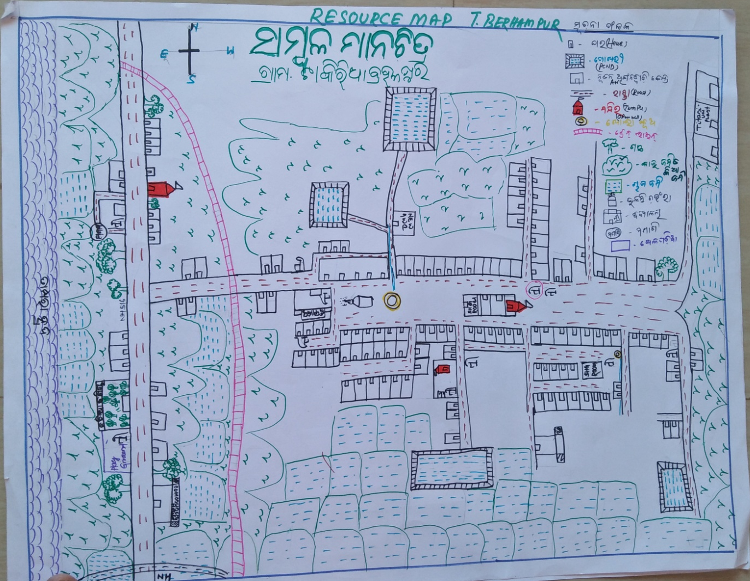
1) Resource Map
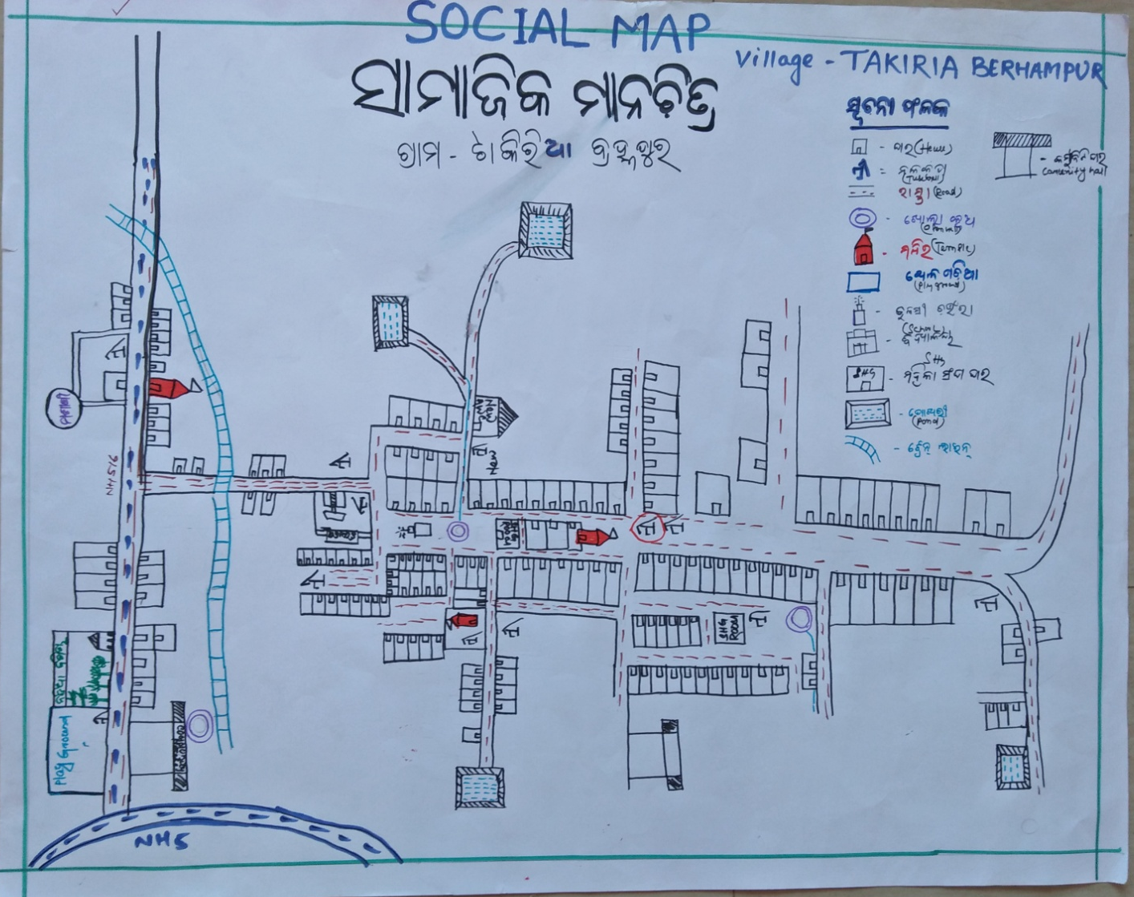
2) Social Map
23 . Water Bodies;-
SN | Surface water Bodies | Period for Which water Available | Purpose of Use | For Each purpose indicate Month (From –to) | Who Manage
1 | River & Stream | 0 | 0 | 0 | 0
2 | Chanel & Canal | 0 | 0 | 0 | 0
3 | Lake | 08 Month | irrigation | 0 | Gov
4 | Pond | 9 month | Bath, Wash, Irrigation | Same | Panchayat
5 | Open Dug well | 9 month | Bath ,Wash | same
(Mark on Resource Map)

24. Seasonal Calendar For Resources Availability:-
 | Jan | Feb. | Mar | Apr | May | June | july | Avug | Sept | Oct | Nov | Dec
Capture Fishing | 0 | 0 | 0 | 0 | 0 | 0 | 0 | 0 | 0 | 0 | 0 | 0
Culture Fishing | 0 | 0 | 0 | 0 | 0 | 0 | √ | √ | √ | √ | 0 | 0
Aquatic plant collection | 0 | 0 | 0 | 0 | 0 | 0 | 0 | 0 | 0 | 0 | 0 | 0
Agriculture | 0 | 0 | 0 | 0 | 0 | 0 | √ | √ | √ | √ | √ | √
Kaju collecting | 0 | 0 | 0 | √ | √ | √ | 0 | 0 | 0 | 0 | 0 | 0
Keoda collection |  | √ | √ | √ | √ | √ | √√√ | √√√ | √√√ | √√ | √

25. Hazard & Vulnerability Mapping :-
SN | Type of Hazard | Year of Hazard | Period of Hazard | If flood days when water logging | Areas Inundated
1 | Super cyclone | 1999 | October
2 | phailin | 2014 | October

26. Time &Trained Analysis of Resource Vulnerability:-
SN | Year | Type Hazard/Event | Effect/ affect Water resourse
1 | Super cyclon | 1999
2 | phailin | 2014

